1. **Introduction**

Steller is an E-Commerce website that provides a user-friendly interface and a very easy process for buyers to select and order clothes online. We provide a large collection of clothes in three categories i.e.Men, Women and children. With Php working in background, we have the interface of HTML and CSS.

Online shopping is the process whereby consumers directly buy goods or services from a seller in real-time, without an intermediary service, over the Internet. It is a form of electronic commerce. This project is an attempt to provide the advantages of online shopping to customers of a real shop.

The effective use of “STELLER” as it provides a common platform to different categories of people and directly connects them to a whole world of shopping.

**1.1 Purpose**

The objective of the project is to make a website to purchase items in an existing shop. In order to build such a website complete web support need to be provided. A complete and efficient website which can provide the online shopping experience is the basic objective of the project.

**1.2 Scope**

This system can be implemented to any shop in the locality or to multinational branded shops having retail outlet chains. The system recommends a facility to accept the orders 24*7 and a home delivery system which can make customers happy. Shops are providing an online portal where their customers can enjoy easy shopping from anywhere.

**1.3 Motivation**

This website reduces the task of going to market and search hundreds of shops to buy only one cloth. It not only reduce effort of going to market but also save time.

**1.4 Overview**

**a) Existing System :**

* Various websites like amazon and flipkart.

**b) Drawbacks:**

* Colour and size confusion
* Delay delivery.

**c) Proposed System :**

This website provides online plateform for shopping with variety of clothes with a very user friendly interface.

**2.Software Requirement Analysis**

The technologies and tools used by me to develop this system are:

**Technologies used:**WAMP,PHP,HTML,CSS,Bootstrap and MySQL.

**Tools Used:** WAMP,Apacheand MySQL.

Let us take an overview on all the tools used in our project-

**PHP**

Stands for "Hypertext Preprocessor." (It is a recursive acronym, if you can understand what that means.) PHP is an HTML-embedded Web scripting language. This means PHP code can be inserted into the HTML of a Web page. When a PHP page is accessed, the PHP code is read or "parsed" by the server the page resides on. The output from the PHP functions on the page are typically returned as HTML code, which can be read by the browser. Because the PHP code is transformed into HTML before the page is loaded, users cannot view the PHP code on a page. This make PHP pages secure enough to access databases and other secure information.

**WAMP**

Stands for "Windows, Apache, MySQL, and PHP." WAMP is a variation of [LAMP](https://techterms.com/definition/lamp) for Windows systems and is often installed as a [software](https://techterms.com/definition/software) bundle (Apache, MySQL, and PHP). It is often used for [web development](https://techterms.com/definition/web_development) and internal testing, but may also be used to serve live websites.

The most important part of the WAMP package is [Apache](https://techterms.com/definition/apache) (or "Apache HTTP Server") which is used run the [web server](https://techterms.com/definition/web_server) within Windows. By running a local Apache web server on a Windows machine, a web developer can test [webpages](https://techterms.com/definition/webpage) in a [web browser](https://techterms.com/definition/web_browser) without publishing them live on the Internet.

**SQL**

Structured Query Language or SQL is a standard Database language which is used to create, maintain and retrieve the relational database. It is particularly used to work with structured data where there is relations associated within the data itself.

**HTML & CSS**

HTML (the Hypertext Markup Language) and CSS (Cascading Style Sheets) are two of the core technologies for building Web pages. HTML provides the structure of the page, CSS the (visual and aural) layout, for a variety of devices. Along

with graphics and scripting, HTML and CSS are the basis of building Web pages and Web Applications.

**2.1 Problem Definition**

Now it’s the time to discuss some of the problems that we face before-

Here both user as well as the admin face the problem. This project avoid the complexity of setting and managing product and orders manually. It will help you to manage all the sections automatically.User can receive their order and product information whenever they login. Initially we will be setting the maximum workloads for the Admin in a day, week and month. Main challenge is to manage tracking of the orderwithout the presence of any guidance. By using this software it will be very easy to trackorder by users. After working on this project user will not have to go here and there for different clothes.

**2.2 Modules and their functionalities**

* *USER-* User will be able to view the variety of clothes.
* *ADMIN -* He can add clothes and can change the clotheswhenever required.

**3.Software Design**

This is the designing portion of the project which defines software solutions to one or more sets of problem. One of the main component of software design is the software requirement analysis.

**3.1 Data Flow Diagram**

**3.1.(a) Zero Level DFD**

A context level DFD is the most basic form of DFD. It aims to show how the entire system works at a glance. There is only one process in the system and all the data flows either into or out of this process. Context level DFD’s demonstrates the interactions between the process and external entities.

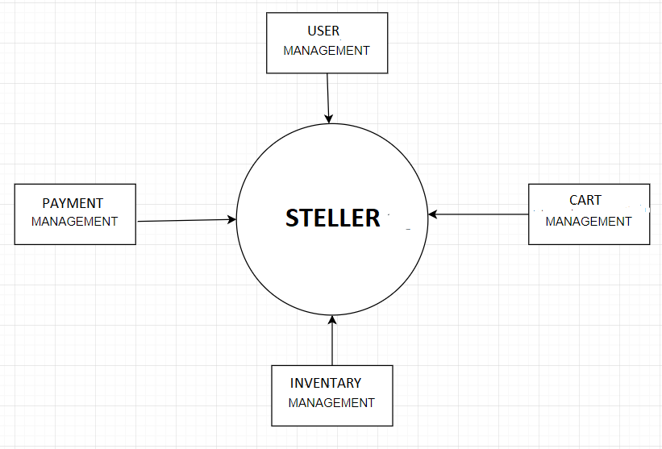

**Fig.3.1.(a) Zero Level DFD**

**3.1.(b) One Level DFD**

Level 1 DFD’s aim to give an overview of the full system. They look at the system in more detail. Major processes are broken down into sub-processes. Level 1 DFD’s a identifies data stores that are used by the major processes.

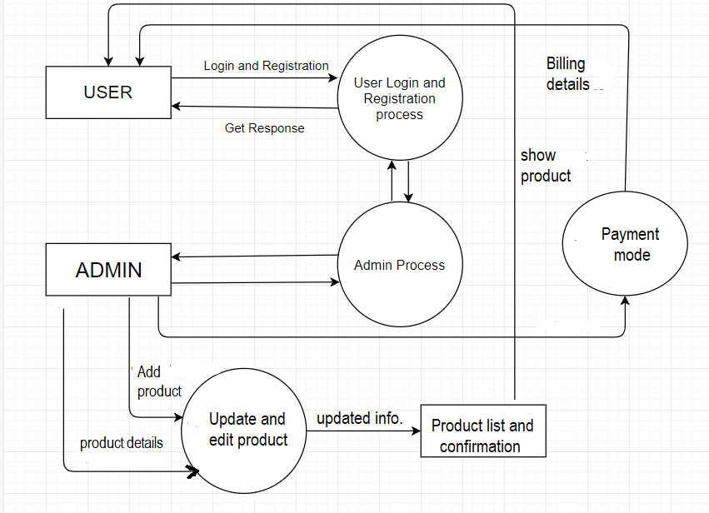

**Fig.3.1.(b) One Level DFD**

**3.2 UML Diagrams**

The UML is a standard visual modelling language intended to be used for modelling business and similar processes.

**3.2.(a) Use Case**

A **use case** is a list of actions or event steps typically defining the interactions between a role (known in the [Unified Modeling Language](https://en.wikipedia.org/wiki/Unified_Modeling_Language) as an [actor](https://en.wikipedia.org/wiki/Actor_(UML))) and a system to achieve a goal. The actor can be a human or other external system. [Use case analysis](https://en.wikipedia.org/wiki/Use-case_analysis) is an important and valuable [requirement analysis](https://en.wikipedia.org/wiki/Requirement_analysis) technique that has been widely used in modern software engineering.

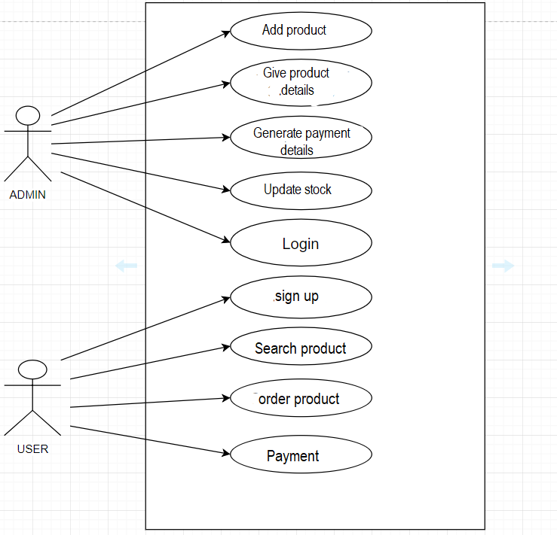**Fig.3.2.(a) Use case**

**3.2.(b) Class Diagram**

A **class diagram** in the Unified Modeling Language (UML) is a type of static structure diagram that describes the structure of a system by showing the system's classes, their attributes, operations (or methods), and the relationships among objects.

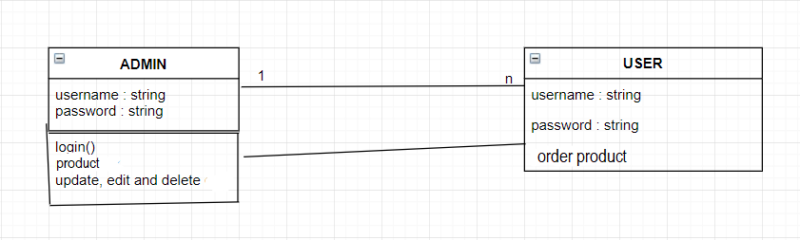

**Fig.3.2.(b) Class Diagram**

**4. Database Diagram**

The **database schema** of a database system is its structure described in a formal language supported by the database management system (DBMS). The term "[schema](https://en.wiktionary.org/wiki/schema)" refers to the organization of data as a blueprint of how the database is constructed (divided into database tables in the case of relational databases). The formal definition of a database schema is a set of formulas (sentences) called integrity constraints imposed on a database. These integrity constraints ensure compatibility between parts of the schema.

**4.1 E-R Diagram**

An entity–relationship model (ER model) describes interrelated things of interest in a specific domain of knowledge. A basic ER model is composed of entity types (which classify the things of interest) and specifies relationships that can exist between instances of those entity types. ER model defines a data or information structure which can be implemented in a database, typically a [relational database](https://en.wikipedia.org/wiki/Relational_database).

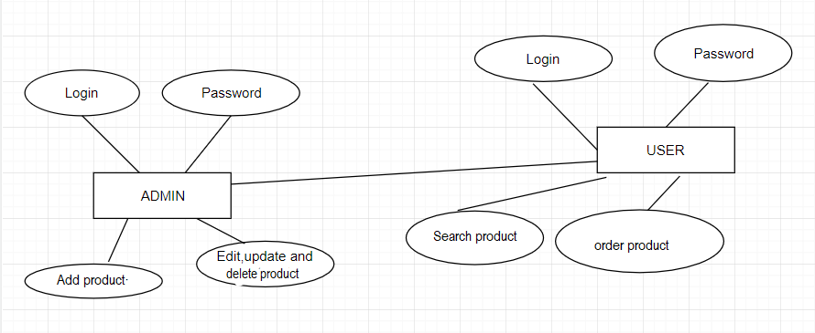

**Fig.4.1 E-R Diagram**

* 1. **Tables**

**Table 1**

**ADMIN TABLE:**

|  |  |  |  |
| --- | --- | --- | --- |
| **SERIAL NO.** | **COLUMN NAME** | **DATATYPE** | **CONSTRAINTS** |
| **1** | Username | varchar(45) | Not Null |
| **2** | Password | varchar(45) | Not Null |

**Table 2**

**2.USER TABLE:**

|  |  |  |  |
| --- | --- | --- | --- |
| **SERIAL NO.** | **COLUMN NAME** | **DATATYPE** | **CONSTRAINTS** |
| **1** | Username | varchar(45) | Not Null |
| **2** | Password | varchar(45) | Not Null |
| **3** | Email | varchar(45) | Not Null |

**Table 3**

**3.PRODUCT TABLE:**

|  |  |  |  |
| --- | --- | --- | --- |
| **SERIAL NO.** | **COLUMN NAME** | **DATATYPE** | **CONSTRAINTS** |
| **1** | productID | int(255) | Not Null |
| **2** | category | varchar(255) | Not Null |
| **3** | choice1 | varchar(255) | Not Null |
| **4** | choice2 | varchar(255) | Not Null |
| **5** | choice3 | varchar(255) | Not Null |
| **6** | choice4 | varchar(255) | Not Null |
| **7** | Add cart | varchar(255) | Not Null |

**Table 4**

**4.BILLING TABLE:**

|  |  |  |  |
| --- | --- | --- | --- |
| **SERIAL NO.** | **COLUMN NAME** | **DATATYPE** | **CONSTRAINTS** |
| **1** | Payment mode | int(45) | Not Null |
| **2** | Billing mode | varchar(250) | Not Null |

**5.User Implementations and Interface**

**5.1 FIRST PAGE**

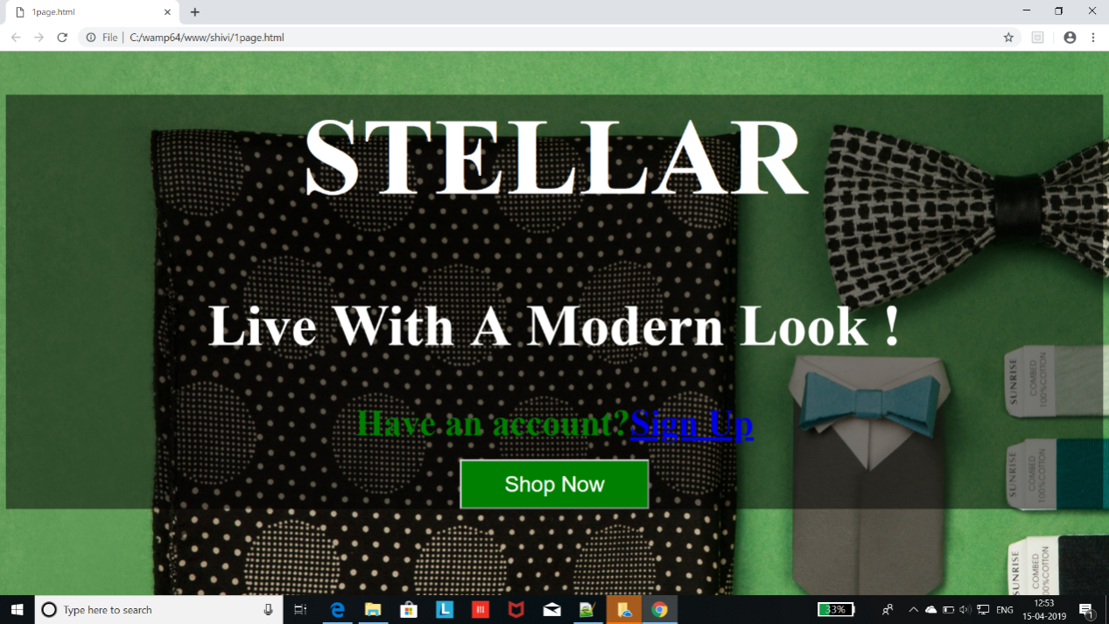

**Fig.5.1 First Page**

This is the first page of our app which shows the logo using Splash Screen which is there for 3 seconds. After that we will move to the home screen automatically.

**5.2 LOGIN PAGE**

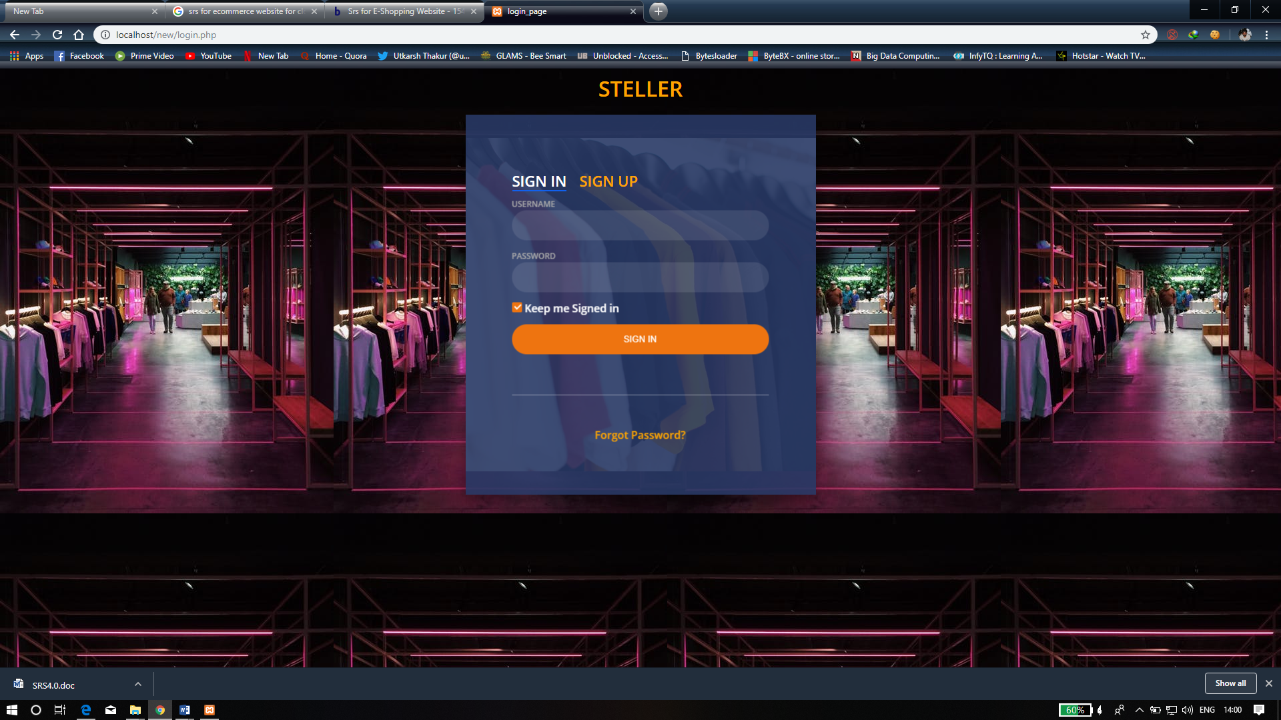

**Fig.5.2 Login Page**

This is the login page where we have to enter email and password which have been work after the approval of validation.

**5.3SIGN UP PAGE**

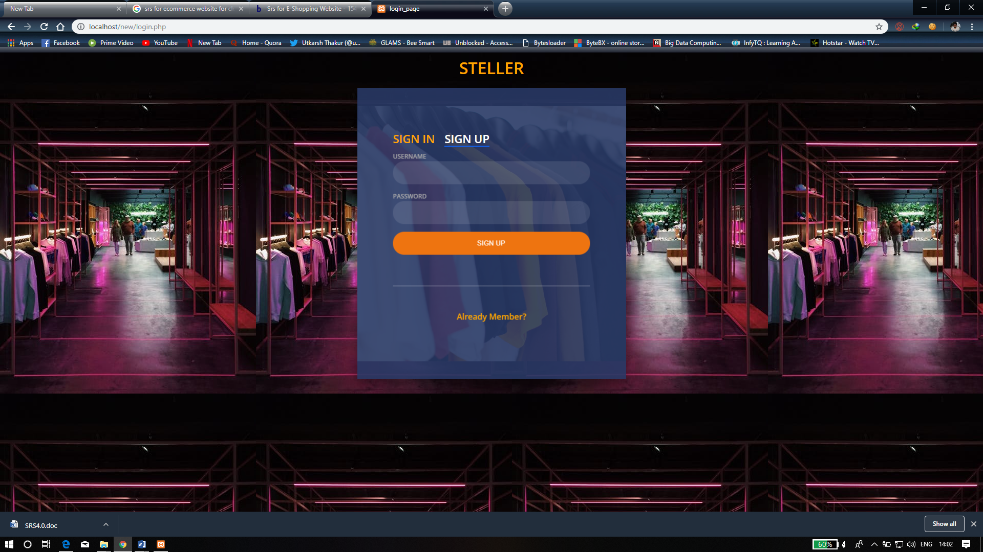

**Fig.5.3 Sign up Page**

This is the registration page where new user can register where the new user can register by entering the username , Email id and Password.

**5.4 CATALOGUE**

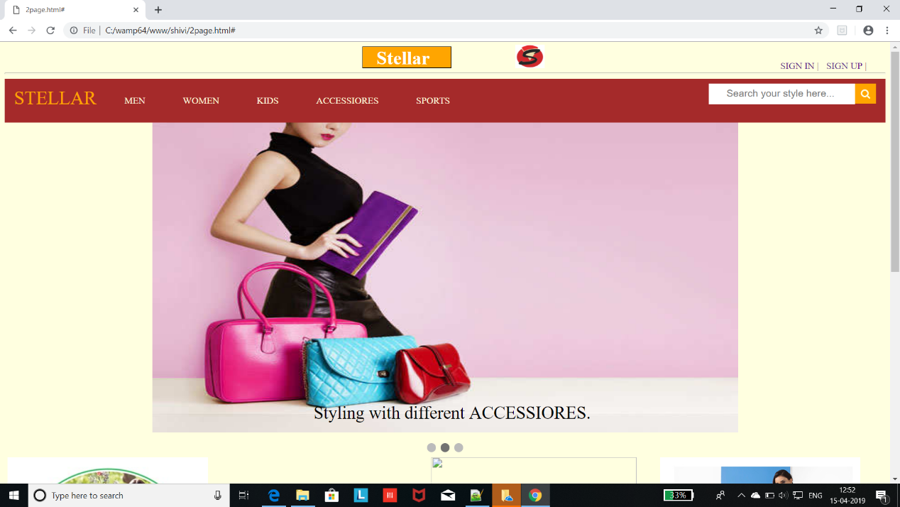

**Fig.5.4CATALOGUE**

**5.5MEN DIVISION**

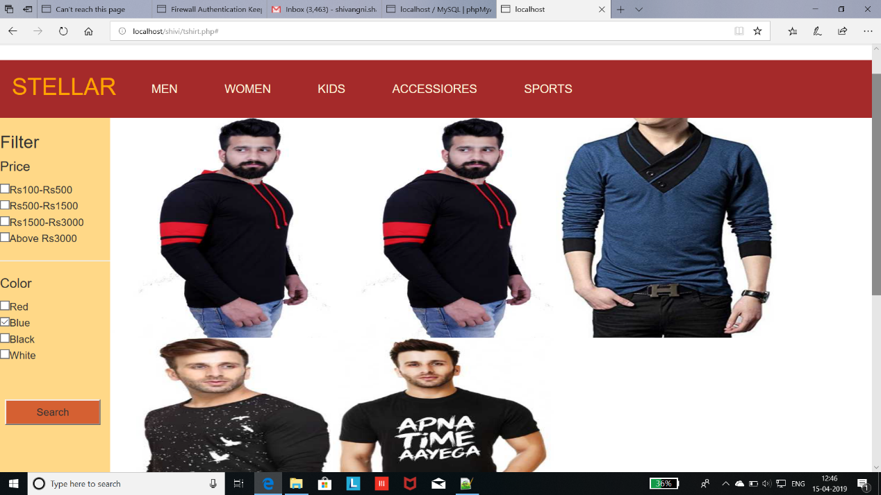

**Fig.5.5MEN DIVISION**

**BIBLIOGRAPHY**

1. www.geeksforgeeks.com

2. www.youtube.com

3. www.udemy.com

4. https://stackoverflow.com

**6.APPENDICES**

**1.Registration Code**

<?php

session_start();

$con=mysqli_connect('localhost','root');

if($con){

echo "connection successful";

}

else{

echo "connection unsuccessful";

}

mysqli_select_db($con,'shubh2');

$name= $_POST['username'];

$pass=$_POST['password'];

$q="select * from user where name='$name' && password='$pass'";

$result=mysqli_query($con,$q);

echo $result ;

$num=mysqli_num_rows($result);

if($num==1){

echo "existing user";

}

else{

$qy="insert into shubh2(name,password) values ('$name','$pass')";

mysqli_query($con,$qy);

}

?>

**2. Login Code**

<!DOCTYPE html>

<html lang="en" >

<head>

<meta charset="UTF-8">

<title>login_page</title>

<link rel='stylesheet prefetch' href='https://fonts.googleapis.com/css?family=Open+Sans:600'>

<link rel="stylesheet" href="./style.css">

</head>

<body>

<h1><center>STELLER</center></h1>

<div class="login-wrap">

<div class="login-html">

<input id="tab-1" type="radio" name="tab" class="sign-in" checked><label for="tab-1" class="tab">Sign In</label>

<input id="tab-2" type="radio" name="tab" class="sign-up"><label for="tab-2" class="tab">Sign Up</label>

<div class="login-form">

<form class="sign-in-htm" action="validation.php" method="POST">

<div class="group">

<label for="user" class="label">Username</label>

<input id="username" name="username" type="text" class="input">

</div>

<div class="group">

<label for="pass" class="label">Password</label>

<input id="password" name="password" type="password" class="input" data-type="password">

</div>

<div class="group">

<input id="check" type="checkbox" class="check" checked>

<label for="check"><span class="icon"></span> Keep me Signed in</label>

</div>

<div class="group">

<input type="submit" class="button" value="Sign In">

</div>

<div class="hr"></div>

<div class="foot-lnk">

<a href="#forgot">Forgot Password?</a>

</div>

</form>

<form class="sign-up-htm" action="registration.php" method="POST">

<div class="group">

<label for="user" class="label">Username</label>

<input id="username" name="username" type="text" class="input">

</div>

<div class="group">

<label for="pass" class="label">Password</label>

<input id="password" name="password" type="password" class="input" data-type="password">

</div>

<div class="group">

<input type="submit" class="button" value="Sign Up">

</div>

<div class="hr"></div>

<div class="foot-lnk">

<label for="tab-1">Already Member?</a>

</div>

</form>

</div>

</div>

</div>

</body>

</html>

**3. Main website Code**

<?php

session_start();

$conn1=mysqli_connect("localhost","root","","e-commerce");

if(!isset($_SESSION['username'])){

header('location:login.php')

}

if(isset($_POST["add_to_cart"]))

{

if(isset($_SESSION["shopping_cart"]))

{

$item_array_id=array_column($_SESSION["shopping_cart"],"item_id");

if(!in_array($_GET["id"],$item_array_id))

{

$count=count($_SESSION["shopping_cart"]);

$item_array = array(

'item_name' => $_POST["hidden_name"],

'item_price' => $_POST["hidden_price"],

'item_quantity' => $_POST["quantity"],

);

$_SESSION["shopping_cart"][$count]=$item_array;

}

else

{

echo '<script>alert("Item Already added")</script>';

echo '<script>window.location="third.php"</script>';

}

}

else

{

$item_array = array(

'item_name' => $_POST["hidden_name"],

'item_price' => $_POST["hidden_price"],

'item_quantity' => $_POST["quantity"]

);

$_SESSION["shopping_cart"][0]=$item_array;

}

}

?>

<html>

<head>

<link rel="stylesheet" href="https://cdnjs.cloudflare.com/ajax/libs/font-awesome/4.7.0/css/font-awesome.min.css">

<script src="https://ajax.googleapis.com/ajax/libs/jquery/2.2.0/jquery.min.js"></script>

<link rel="stylesheet" href="https://maxcdn.bootstrapcdn.com/bootstrap/3.3.6/css/bootstrap.min.css"></link>

<script src="https://maxcdn.bootstrapcdn.com/bootstrap/3.3.6/js/bootstrap.min.js"></script>

<link rel="stylesheet" href="styles.css">

</head>

<body>

<div class="container">

<h2 class="text-center text-success">WELCOME <?php echo "$_SESSION['username']; ?>"</h2>

<a href="login.php">LOGOUT</a>

</div>

<div class="cc" >

<div>

<div class="box"><h1>Stellar</h1></div>

<img class="c" src="p2logo.png">

<a href="" class="a" >SIGN IN |</a>

<a href="" class="b" >SIGN UP |</a>

</div>

<hr>

<div class="topnav">

<a href="home" style="color:orange";><font size="6">STELLAR</font></a>

<div class="men1">

<button class="men2"><a href="home.html">MEN</a></button>

<div class="men">

<a href="tshirt.php">T-shirts</a>

<a href="#">Trousers</a>

<a href="#">Jeans</a>

<a href="#">Jackets</a>

<a href="#">Shoes</a>

<a href="#">Shirts</a>

</div></div>

<div class="men1">

<button class="men2"><a href="admin.html">WOMEN</a></button>

<div class="men">

<a href="#">Tops</a>

<a href="#">saree</a>

<a href="#">Dresses</a>

<a href="#">Suits</a>

<a href="#">Footwear</a>

<a href="#">Gowns</a>

</div></div>

<div class="men1">

<button class="men2"><a href="owner.html">KIDS</a></button>

<div class="men">

<a href="#">Shirt</a>

<a href="#">Jeans</a>

<a href="#">Dresses</a>

<a href="#">Frock</a>

<a href="#">Footwear</a>

<a href="#">Bags</a>

</div></div>

<div class="men1">

<button class="men2"><a href="customer.html">ACCESSIORES</a></button>

<div class="men">

<a href="#">Bags</a>

<a href="#">Jwellery</a>

<a href="#">Watches</a>

<a href="#">Bracelet</a>

<a href="#">Sunglasses</a>

<a href="#">Wallet</a>

</div></div>

<div class="men1">

<button class="men2"><a href="About.html">SPORTS</a></button>

<div class="men">

<a href="#">FootBall</a>

<a href="#">Sport shoes</a>

<a href="#">Shorts</a>

<a href="#">Track suit</a>

<a href="#">Badminton</a>

</div></div>

</div>

<form action="#" method="post">

<div class="filter">

<h3>Filter</h3>

<h4>Price</h4>

<input type="checkbox" name="c1">Rs100-Rs500<br>

<input type="checkbox" name="c2">Rs500-Rs1500<br>

<input type="checkbox" name="c3">Rs1500-Rs3000<br>

<input type="checkbox" name="c4">Above Rs3000

<hr>

<h4>Color</h4>

<input type="checkbox" name="c5">Red<br>

<input type="checkbox" name="c6">Blue<br>

<input type="checkbox" name="c7">Black<br>

<input type="checkbox" name="c8">White<br>

<input type="submit" name="submit" class="butn" value="Search">

</div>

</div>

</form>

<?php { ?>

<?php

$servername = "localhost";

$username = "root";

$password = "";

$conn1=mysqli_connect($servername,$username,$password,"e-commerce");

$img="select img from men";

$sql1="select * from men where color='blue'";

$sql2="select img from men where price between 100 and 500";

$sql3="select img from men where color ='red'";

$sql4="select img from men where price between 500 and 1500";

$sql5="select img from men where color ='black'";

$sql6="select img from men where price between 1500 and 3000";

$sql7="select img from men where color ='white'";

$sql8="select img ,price,details from men where price greator than 3000";

$result=mysqli_query($conn1,$img);

$res1=mysqli_query($conn1,$sql1);

$res2=mysqli_query($conn1,$sql2);

$res3=mysqli_query($conn1,$sql3);

$res4=mysqli_query($conn1,$sql4);

$res5=mysqli_query($conn1,$sql5);

$res6=mysqli_query($conn1,$sql6);

$res7=mysqli_query($conn1,$sql7);

$res8=mysqli_query($conn1,$sql8);

$get_img="select img from men";

while($rows1 = mysqli_fetch_array($res1) ) {

if(isset($_POST['submit'])){

if(!empty($_POST['c6'])){?>

<div class="col-md-4">

<form method="post" action="third.php?action=add>

<div style="border:1px solid #333; background-color:#f1f1f1; border-radius:5px; padding:16px">

<imgsrc="<?php echo $rows1["img"]; ?>" class="img-responsive"width="300" alt="shivi" height="300"/><br/>

<h4 class="text-info"><?php echo $rows1["name"]; ?></h4>

<h4 class="text-danger">$ <?php echo $rows1["price"]; ?></h4>

<input type="text" name="quantity" class="form-control" value="1" />

<input type="hidden" name="hidden_name" value="<?php echo $rows1["name"]; ?>" />

<input type ="hidden" name="hidden_price" value="<?php echo $rows1["price"]; ?>" />

<input type ="submit" name="add_to_cart" style="margin-top:5px;" class="btnbtn-success" value="add to cart" />

<input type ="submit" name="buy now" style="margin-top:5px;" class="btnbtn-success" value="buy now" onclick="1page.html"/>

</div>

</form>

</div>

<?php } ?>

<?php } ?><?php } ?>

<?php

while($rows2 = mysqli_fetch_array($res2) ) {

if(isset($_POST['submit'])){

if(!empty($_POST['c1'])){?>

<imgsrc="<?php echo $rows2["img"]; ?>" class="image" width="300" alt="shivi" height="300">;

<?php } ?>

<?php } ?>

<?php } ?>

<?php

while($rows3 = mysqli_fetch_array($res3) ) {

if(isset($_POST['submit'])){//to run PHP script on submit

if(!empty($_POST['c5'])){?>

<imgsrc="<?php echo $rows3["img"]; ?>" class="image" width="300" alt="shivi" height="300">;

<?php } ?>

<?php } ?>

<?php } ?>

<?php

while($rows4 = mysqli_fetch_array($res4) ) {

if(isset($_POST['submit'])){//to run PHP script on submit

if(!empty($_POST['c2'])){?>

<imgsrc="<?php echo $rows4["img"]; ?>" class="image" width="300" alt="shivi" height="300">;

<?php } ?>

<?php } ?>

<?php } ?>

<?php

while($rows5 = mysqli_fetch_array($res5) ) {

if(isset($_POST['submit'])){//to run PHP script on submit

if(!empty($_POST['c7'])){?>

<imgsrc="<?php echo $rows5["img"]; ?>" class="image" width="300" alt="shivi" height="300">;

<?php } ?>

<?php } ?>

<?php } ?>

<?php

while($rows6 = mysqli_fetch_array($res6) ) {

if(isset($_POST['submit'])){//to run PHP script on submit

if(!empty($_POST['c3'])){?>

<imgsrc="<?php echo $rows6["img"]; ?>" class="image" width="300" alt="shivi" height="300">;

<?php } ?>

<?php } ?>

<?php } ?>

<?php

while($rows7 = mysqli_fetch_array($res7) ) {

if(isset($_POST['submit'])){//to run PHP script on submit

if(!empty($_POST['c8'])){?>

<a href="a.php?$a=$rows7['img'];"><imgsrc="<?php echo $rows7["img"];?>" class="image" width="300" alt="shivi" height="300">;</a>

<?php } ?>

<?php } ?>

<?php } ?>

<?php } ?>

<div style="clear:both"></div>

<br/>

<h3>Order Details</h3>

<div class=table-responsive></div>

<table class="table table-bordered">

<tr>

<th width="10%">Item Name </th>

<th width="10%">quantity </th>

<th width="20%">price </th>

<th width="15%">total </th>

<th width="5%">Action </th>

</tr>

<?php

if(!empty($_SESSION["shopping_cart"]))

{

$total=0;

foreach($_SESSION["shopping_cart"] as $keys => $values)

{

?>

<tr>

<td><?php echo $values["item_name"]; ?></td>

<td><?php echo $values["item_quantity"]; ?></td>

<td><?php echo $values["item_price"]; ?></td>

<td><?php echo (int)$values["item_quantity"] *(int) $values["item_price"] ;?></td>

<td><a href="third.php?action=delete&id=<?php echo $values["item_id"]; ?>"><span class="text-danger">Remove</span></a></td>

</tr>

<?php

$total=(int)$total+((int)$values["item_quantity"] * (int)$values["item_price"]);

}

}

?>

<tr>

<td colspan="3" align="right">Total</td>

<td align="right"><?php echo number_format($total,2); ?></td>

<td></td>

</tr>